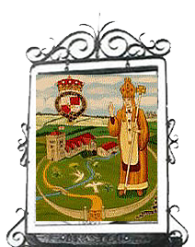
Brasted Parish Council
c/o PO Box 576, Sevenoaks TN13 9RT
Tel: 01732 455374 clerk@brastedparishcouncil.gov.uk

You are invited to
Annual Parish Meeting
Monday 13 April 2026
7 P.M.
Brasted Recreation Ground Pavilion
AGENDA
- Welcome, Introductions and Apologies for absence
- Minutes of the Annual Parish Meeting held on 14 April 2025
- Brasted Parish Council Chair’s Report
- Community Reports

Kent County Council Cllr Nigel Williams
Sevenoaks District Council District Cllrs Michelle Alger, Sandra Robinson, Nigel Williams
Kent Police To be confirmed
St Martin’s Church Roger Rogowski
Chart Recreation Ground Committee John Pym & Colin Hill
Tennis Club To be confirmed

- Further matters for discussion & questions from parishioners

All parishioners are most welcome to attend
Refreshments will be available

